**AEM Notes**

**Event Handler**

Scenario –

Have to send an email to the editor, as soon as any page is created under specific content path

The sling level events can be captured by implementing the event handler interface.

A property called **EventConstants.EVENT_TOPIC** has to be defined which signifies what event has to be captured.

Go to <http://localhost:4502/system/console/events>

Or goto <http://localhost:4502/system/console/bundles> and OSGI -> Events.

It will list down all the events that are received with the following information.

Received | Event Topic | Event Properties

Basic Event Topics

For DAM - **com/day/cq/dam**

For Page - **com/day/cq/wcm/core/page**

For Replication **– com/day/cq/replication**

**For page creation, event type will be ‘PageCreated’**

Schedulers

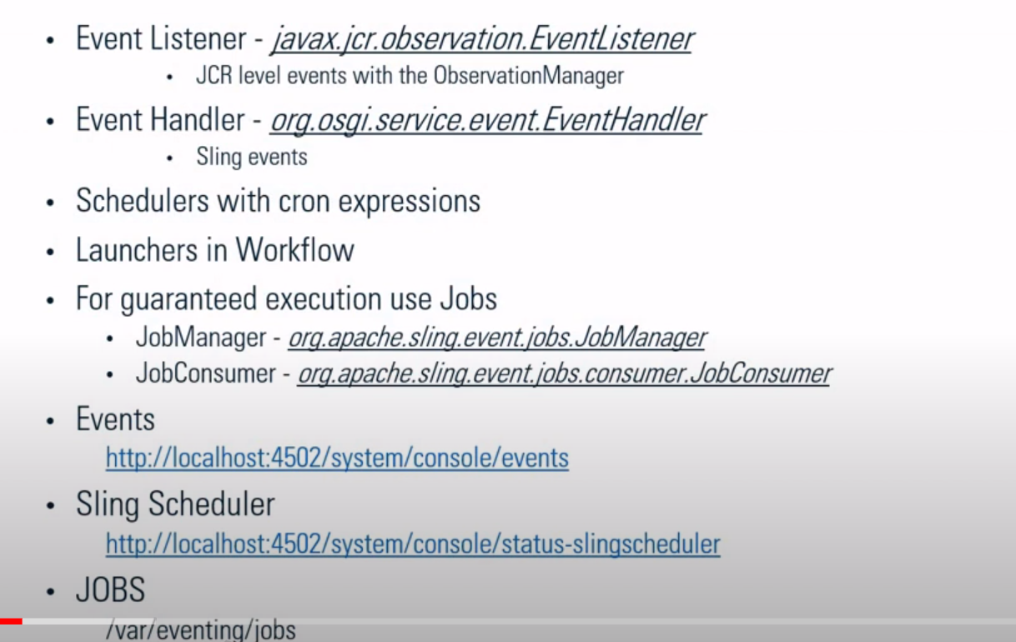

* Schedule on activation
* Unschedule on deactivation
* Implement Runnable Interface and override run() method

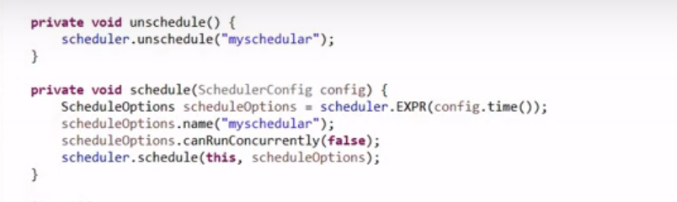

Clear cache

**JSPs**

<http://localhost:4502/system/console/slingjsp>

Button -> recompile all jsps

All compiled JSPs are cleared

**Sightly/HTML**

<http://localhost:4502/system/console/scriptcache>

Individual files can be removed

Or Clear cache (button to remove all the HTMLs)

**Client Libraries**

<http://localhost:4520/libs/granite/ui/content/dumplibs.rebuild.html>

Invalidate Cache

Rebuild Libraries

(Client libraries which are cached under /var/clientlibs)

**Clear Java/Sightly classes**

Go to bundles console and find the bundle ID

Go to quickstart -> launchpad -> felix

All the bundles will be present here

Identify the bundle with bundle ID -> Go inside bundle folder -> Data -> classes

Delete the classes folder

**Clearing Dispatcher Cache**

Go to Author -> <http://localhost:4502/miscadmin#/etc/replication/agents.publish>

Create a replication agent page using Replication Agent template.

Serialization type -> Default

Transport URI - <http://localhost:4503/bin/receive?sling:authRequestLogin=1>

(This is for replicating the content from author to publisher)

Go to publisher -> <http://localhost:4503/miscadmin#/etc/replication/agents.publish>

Create a replication agent page using Replication Agent template.

Serialization type -> Dispatcher Flush

Transport URI - <http://localhost:8000/dispatcher/invalidate.cache>

(This is for sending a invalidate request to dispatcher, for invalidating the content)

Under Triggers -> Select Ignore Default & On Modification checkboxes, so that any updates happens on publisher will trigger a request to dispatcher to invalidate the content.

So once we replicate the content from author to publisher, as there will be update on the content on the publisher, a request would be sent to dispatcher to invalidate the cache.

This way all the HTML, CSS, JS and other related resources would be invalidated and all its child related resources will also be invalidated.

**Client Libraries**

Site grows bigger -> Difficult to manage the resources

